## Clean the Smelly Code

You are given a C# application ([Code-Tuning-and-Optimization-Homework.zip](10.%20Code-Tuning-and-Optimization-Homework.zip)) which displays an animated 3D model of the Solar system.

1. Use a profiler to find the places in its source code which cause significant performance degradation (bottlenecks).

* Provide a screenshot of the profiler’s result and indicate the place in the source code where the bottleneck resides (name of the file, line of code).

1. Make a quick fix in the source code in order to significantly improve the performance. Test the code after the fix for correctness + performance.

Performance analysis before the tuning:

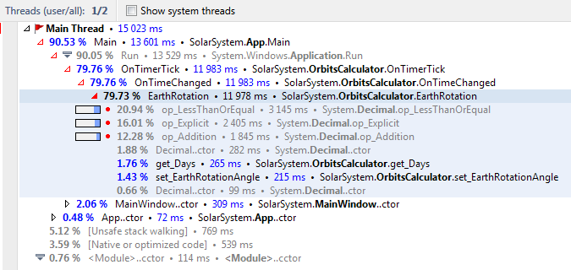

Performance tuning: EarthRotation method uses a loop with a decimal counter, which is cast to a double in the loop. After changing the counter type to double and removing the cast:

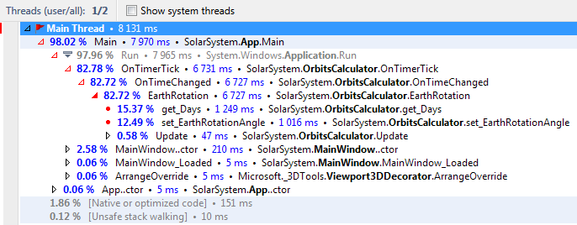

Performance tuning 2: In the same method the Step increment was changed from 0.00005 to 0.003 because the slowest rotation speed is 0.1 days per second. Having in mind that the human brain perceives object moving faster than 30 times per second as constant non-interrupted motion, the new increment step is 0.1 days per second / 30 frames per second = 0.00333, thus 0.003 would do just fine.

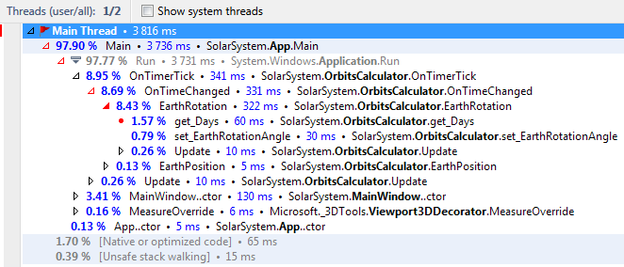

Conclusion: Performance tuned 393.7 %.